Factor Analysis

Notes
Output Created |  | 28-JUN-2021 13:49:23
Comments
Input | Data | /Users/coderlax/Desktop/EO Hackathon/Asia/Quality of Life/COVID/Zscore/Z1.sav
Input | Active Dataset | DataSet4
Input | Filter | <none>
Input | Weight | <none>
Input | Split File | <none>
Input | N of Rows in Working Data File | 91
Missing Value Handling | Definition of Missing | MISSING=EXCLUDE: User-defined missing values are treated as missing.
Missing Value Handling | Cases Used | LISTWISE: Statistics are based on cases with no missing values for any variable used.
Syntax |  | FACTOR  /VARIABLES ZConfrimed ZRecovered ZDeadth  /MISSING LISTWISE  /ANALYSIS ZConfrimed ZRecovered ZDeadth  /PRINT UNIVARIATE INITIAL CORRELATION KMO EXTRACTION ROTATION  /FORMAT SORT  /PLOT EIGEN  /CRITERIA FACTORS(3) ITERATE(25)  /EXTRACTION PC  /CRITERIA ITERATE(25)  /ROTATION VARIMAX  /METHOD=COVARIANCE.
Resources | Processor Time | 00:00:00.17
Resources | Elapsed Time | 00:00:00.00
Resources | Maximum Memory Required | 1984 (1.938K) bytes

Descriptive Statistics
 | Mean | Std. Deviation | Analysis N
ZConfrimed | .72534333 | .999999905 | 91
ZRecovered | .71647222 | 1.000000142 | 91
ZDeadth | .68136300 | 1.000000233 | 91

Correlation Matrix
 |  | ZConfrimed | ZRecovered | ZDeadth
Correlation | ZConfrimed | 1.000 | .957 | .979
Correlation | ZRecovered | .957 | 1.000 | .988
Correlation | ZDeadth | .979 | .988 | 1.000

KMO and Bartlett's Testª
Kaiser-Meyer-Olkin Measure of Sampling Adequacy. |  | .656
Bartlett's Test of Sphericity | Approx. Chi-Square | 627.509
Bartlett's Test of Sphericity | df | 3
Bartlett's Test of Sphericity | Sig. | <.001

a. Based on correlations

Communalities
 | Raw |  | Rescaled
 | Initial | Extraction | Initial | Extraction
ZConfrimed | 1.000 | 1.000 | 1.000 | 1.000
ZRecovered | 1.000 | 1.000 | 1.000 | 1.000
ZDeadth | 1.000 | 1.000 | 1.000 | 1.000

Extraction Method: Principal Component Analysis.

Total Variance Explained
 | Component | Initial Eigenvaluesª |  |  | Extraction Sums of Squared Loadings
 | Component | Total | % of Variance | Cumulative % | Total | % of Variance | Cumulative %
Raw | 1 | 2.950 | 98.320 | 98.320 | 2.950 | 98.320 | 98.320
Raw | 2 | .044 | 1.473 | 99.793 | .044 | 1.473 | 99.793
Raw | 3 | .006 | .207 | 100.000 | .006 | .207 | 100.000
Rescaled | 1 | 2.950 | 98.320 | 98.320 | 2.950 | 98.320 | 98.320
Rescaled | 2 | .044 | 1.473 | 99.793 | .044 | 1.473 | 99.793
Rescaled | 3 | .006 | .207 | 100.000 | .006 | .207 | 100.000

Total Variance Explained
 | Component | Rotation Sums of Squared Loadings
 | Component | Total | % of Variance | Cumulative %
Raw | 1 | 1.539 | 51.299 | 51.299
Raw | 2 | 1.443 | 48.103 | 99.403
Raw | 3 | .018 | .597 | 100.000
Rescaled | 1 | 1.539 | 51.299 | 51.299
Rescaled | 2 | 1.443 | 48.103 | 99.403
Rescaled | 3 | .018 | .597 | 100.000

Extraction Method: Principal Component Analysis.
a. When analyzing a covariance matrix, the initial eigenvalues are the same across the raw and rescaled solution.

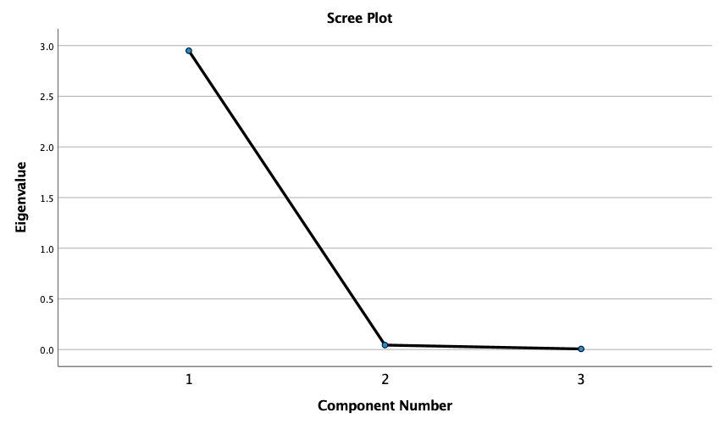

Component Matrixª
 | Raw |  |  | Rescaled
 | Component |  |  | Component
 | 1 | 2 | 3 | 1 | 2 | 3
ZDeadth | .998 | -.024 | -.064 | .998 | -.024 | -.064
ZRecovered | .990 | -.135 | .040 | .990 | -.135 | .040
ZConfrimed | .987 | .159 | .024 | .987 | .159 | .024

Extraction Method: Principal Component Analysis.ª
a. 3 components extracted.

Rotated Component Matrixª
 | Raw |  |  | Rescaled
 | Component |  |  | Component
 | 1 | 2 | 3 | 1 | 2 | 3
ZRecovered | .806 | .592 | .023 | .806 | .592 | .023
ZDeadth | .729 | .673 | .126 | .729 | .673 | .126
ZConfrimed | .598 | .800 | .038 | .598 | .800 | .038

Extraction Method: Principal Component Analysis.
Rotation Method: Varimax with Kaiser Normalization.ª
a. Rotation converged in 3 iterations.

Component Transformation Matrix
Component | 1 | 2 | 3
1 | .717 | .694 | .063
2 | -.695 | .719 | .000
3 | .046 | .043 | -.998

Extraction Method: Principal Component Analysis.
Rotation Method: Varimax with Kaiser Normalization.

